VDR 3 Prototype
Max Jones
Mason Gibson
Wesley Jean-Pierre
Anthony Wuerth
Andrew McClung
12/05/2023

Team 515

Current State of Design:
Team 515’s selected design is a conveyer belt system that will have a part intake feeding the top of conveyer where the bearing retainers will slide down to the bottom of the conveyer and roll over a paint applicator to get a full 360-degree coating of Dykem Layout Fluid. The bearing retainers will then be delivered into a dispensing mechanism that is still being designed. Further testing must be done on the drying properties of the Dykem Layout Fluid to ensure the perfect paint stripe is not tampered with during dispensing. We currently have a prototype of our part painting system as seen below.
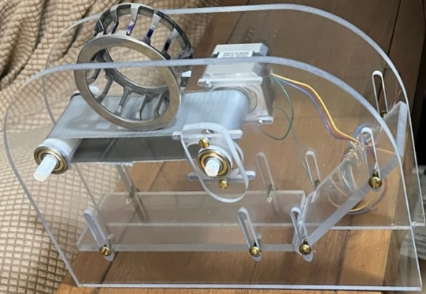
Figure 1:Bearing Painter Prototype
Future Work:
Team 515’s future work will include in-depth testing with the Dykem Layout Fluid. This will include a resilience test. This will test how certain materials which we would like to use for our design will react to the paint, such as the conveyer belt rubber or application materials. The second test with the Dykem will be an application test. This will compare multiple materials that may be used for the application of the Dykem onto the bearing against each other to see which material does the best job of giving us complete 360-degree paint coverage while keeping the paint on excess parts of the retainer to a minimum. The material's ability to hold the paint and transport it via the capillary effect will also be observed in this experiment. The last test we will be doing with the Dykem will be to determine the time it takes for the layout fluid to dry on the retainer. This is a very important metric for us in developing a design which can properly dispense the bearings without negatively impacting the paint strip that was just applied. We will also be working on the part intake system of our design, to which we may try to integrate some degree of separation between the bearing retainers being fed into the part painting system. This may be done to reduce friction between counter-rotating retainers when being painted.
Problem Areas:
The problem areas that our team has identified with our current selected design is the friction between the bearing retainers being greater than the friction between the bearing retainers and the track that it rides on causing the retainers not to spin over the paint applicator. Another potential problem area that we foresee in the selected design is how the Dykem paint will maintain its moisture throughout the process of paint application without drying up on the paint applicator. Finally, the most important problem area to address is the potential for extraneous or incomplete painting. If the machine cannot paint to the quality standards required of the sponsor, it’s effectively useless. For this reason, large emphasis will be placed on ensuring paint quality.

